**ABSTRACT**

The **Laptop Request Catalog Item** project aims to streamline and automate the process of requesting, approving, and fulfilling laptop hardware within the organization through the **ServiceNow Service Catalog**. This initiative replaces manual or email-based hardware requests with a standardized, transparent, and trackable workflow.

The catalog item enables employees to easily request laptops by selecting predefined options such as laptop type, operating system, and required accessories. Once submitted, the request follows an automated approval process involving the requester’s manager and the IT Hardware fulfillment team. Integration with existing IT Service Management (ITSM) processes ensures proper tracking of requests, adherence to service-level agreements (SLAs), and accurate reporting.

This implementation enhances operational efficiency, reduces processing time, minimizes errors, and improves the employee experience by providing self-service access to IT hardware provisioning. It also offers IT administrators visibility into hardware demand and fulfillment performance through reports and dashboards.

**TABLE OF CONTENT**

**1.Introduction**

**1.1** overview of IT service management(ITSM)

1.2 about servicenow

1.3 problem statement

1.4 objective of the project

1.5 scope and limitations

**2.Existing systems**

2.1 Description of current process

2.2 Drawback of existing systems

**3.Proposed system**

3.1 overview of proposed solutions

3.2 features of the system

3.3 Benefit of automation

**4.System analysis**

4.1 Functional requirement

4.2 Non functional requirement

**5.System design**

5.1 System architecture diagram (only diagram section )

**6.Module description**

6.1 user module

6.2 Admin module

**7.Implementation**

7.1. Overview

7.2 step in implementation

* Laptop request catalogue item
* Update set creation
* Service catalogue item creation
* Add variables
* Create UI policy and action
* Export and retrieve update set
* Testing catalogue item

7.3 result

7.4 Screen shot

**8.Testing**

**9.Result and discussion**

**10.Advantages**

**11.Limitation**

**12.Feature enhancement**

**13. Conclusion**

**14.Reference**

# ****1. INTRODUCTION****

### ****1.1 Overview of IT Service Management (ITSM)****

IT Service Management (ITSM) refers to the set of activities, policies, and procedures implemented by organizations to design, deliver, manage, and continuously improve the way IT is used to serve customers and meet business objectives. It focuses on aligning IT services with organizational goals by adopting a customer-centric and process-driven approach. ITSM encompasses the entire lifecycle of an IT service—from strategy and design to operation and continual improvement—ensuring efficiency, reliability, and quality in service delivery. It promotes better communication between IT teams and business units, enhances productivity through automation and standardization, and ensures compliance with regulatory standards through effective risk and change management.

Frameworks like ITIL (Information Technology Infrastructure Library) provide structured guidance for implementing ITSM best practices, emphasizing areas such as incident management, problem management, change control, and service request fulfillment. Modern ITSM solutions also integrate with advanced technologies like AI, analytics, and cloud computing to enable self-service portals, predictive maintenance, and intelligent automation. By maintaining service level agreements (SLAs) and focusing on continuous service improvement, ITSM helps organizations deliver consistent, high-quality IT services that add measurable business value.

### ****1.2 About ServiceNow****

### ServiceNow is a cloud-based IT Service Management (ITSM) platform that enables organizations to automate, streamline, and optimize their business workflows. It provides a centralized system of record for IT operations, helping enterprises manage incidents, service requests, changes, assets, and other IT processes efficiently. Originally designed for IT service management, ServiceNow has expanded its capabilities to include IT Operations Management (ITOM), IT Business Management (ITBM), HR Service Delivery, Customer Service Management (CSM), and Security Operations. The platform operates on a single, unified architecture that ensures consistency, scalability, and high performance across all modules. One of ServiceNow’s core strengths lies in its ****Service Catalog****, which allows users to request IT services or assets through an intuitive self-service portal, reducing manual effort and improving service delivery. It supports automation through workflows, approvals, and notifications, enabling faster resolution of issues and better compliance with organizational policies. Administrators can easily customize applications, design workflows using ****Flow Designer****, and manage configurations using ****update sets**** without complex coding. ServiceNow also integrates with other enterprise systems and uses analytics and AI to provide insights for continuous improvement. Due to its flexibility, security, and scalability, ServiceNow has become a preferred platform for digital transformation and enterprise service management across industries.

### ****1.3 Problem Statement****

In many organizations, IT service requests—such as laptop or software requests—are handled manually through emails or paper forms. This process is time-consuming, prone to errors, and lacks transparency. Employees face delays, and IT staff spend significant time tracking requests instead of focusing on strategic tasks. Therefore, an automated solution is needed to streamline request management, improve visibility, and enhance service delivery.

### ****1.4 Objectives of the Project****

* To automate IT service request processes using ServiceNow.
* To design and implement a **Laptop Request Catalog Item** for easy submission and tracking.
* To reduce manual intervention and improve efficiency.
* To provide a transparent, user-friendly interface for both users and administrators.
* To demonstrate how ITSM tools like ServiceNow improve overall service quality.

### ****1.5 Scope and Limitations****

**Scope:**

* The project focuses on automating the laptop request process in ServiceNow.
* It includes catalog item creation, variable configuration, UI policies, and testing.
* The solution can be extended to other service requests in the future.

**Limitations:**

• **High Implementation and Licensing Cost:**  
ServiceNow is a premium cloud platform, and its licensing, customization, and maintenance costs can be high, especially for small or medium-sized organizations.

• **Complex Configuration for Beginners:**  
Setting up workflows, catalog items, and business rules often requires prior knowledge of the ServiceNow platform, making the learning curve steep for new administrators.

• **Limited Offline Access:**  
Since ServiceNow is a cloud-based solution, users cannot access the system or raise requests without an active internet connection.

• **Restricted UI Customization:**  
Although ServiceNow provides a modern interface, deep UI customization is limited without using advanced scripting or third-party tools.

• **Dependence on Platform Availability:**  
System downtime or scheduled maintenance on the ServiceNow instance can temporarily disrupt operations.

• **Performance Issues with Large Data Volumes:**  
Instances with very large databases or extensive workflows may experience slower response times if not optimized properly.

• **Integration Challenges:**  
Integrating ServiceNow with legacy or on-premise systems can be complex and may require middleware or additional configuration.

• **Limited Control over Updates:**  
As a SaaS platform, ServiceNow automatically rolls out upgrades. Organizations must test customizations thoroughly to ensure compatibility after each update.

• **Customization vs. Standardization Conflict:**  
Over-customizing the system can make future upgrades difficult, while sticking strictly to standard configurations may limit flexibility.

• **Training and Change Management Needs:**  
Users and administrators require adequate training to adapt to the system’s functionalities and workflows, which can consume time and resources.

• **Dependency on Vendor Support:**  
Critical issues or bugs often require assistance from ServiceNow’s support team, which can delay resolution depending on response times.

• **Limited Mobile Functionality:**  
While ServiceNow offers a mobile app, certain complex catalog forms or workflows may not be fully optimized for mobile devices.

• **Potential Data Security Concerns:**  
Storing sensitive organizational data in a third-party cloud environment may raise security or compliance concerns for some enterprises.

# ****2. EXISTING SYSTEM****

1. **Manual Request Submission:**  
   Users had to submit laptop or IT-related requests through paper forms, emails, or verbal communication. This process was time-consuming, prone to errors, and often resulted in delayed approvals.
2. **Lack of Centralized Tracking:**  
   Requests were tracked individually by IT staff, often using spreadsheets or email threads, making it difficult to monitor status, prioritize urgent requests, or maintain accountability.
3. **Inefficient Approval Process:**  
   Approvals required manual intervention by managers or IT personnel, often leading to bottlenecks. There was no automated workflow to route requests to the correct approvers.
4. **Limited Transparency for Users:**  
   End users had minimal visibility into the status of their requests. They often had to follow up via email or phone, which increased workload for IT staff.
5. **Inconsistent Data Management:**  
   Laptop inventory, request history, and user information were not always maintained in a standardized manner, causing discrepancies and difficulties during audits or reporting.
6. **Delayed Notifications:**  
   Users were not automatically notified when their requests were approved, rejected, or fulfilled, which led to confusion and additional follow-ups.
7. **Error-Prone Process:**  
   Manual entry of request details, approvals, and inventory management often resulted in data errors, miscommunication, or loss of important information.
8. **No Standardized Workflow:**  
   Each department or IT team might have used its own methods for handling requests, resulting in inconsistent processes and a lack of adherence to best practices.
9. **Time-Consuming Reporting:**  
   Generating reports about requests, approvals, or inventory utilization required significant manual effort, limiting timely decision-making by management.
10. **Scalability Challenges:**  
    As organizations grew, manual or semi-automated processes could not handle a larger number of requests efficiently, causing delays and decreased productivity.
11. **Limited Integration:**  
    Existing systems often did not integrate with asset management, HR systems, or other IT management tools, resulting in redundant data entry and fragmented workflows.
12. **High Dependency on IT Staff:**  
    Any delays or errors in request processing were highly dependent on IT personnel’s availability, leading to inconsistent service levels.
13. **Security and Compliance Risks:**  
    Handling sensitive information via email or paper forms increased the risk of data loss or unauthorized access.

# ****3. PROPOSED SYSTEM****

### ****3.1 Overview of Proposed Solution****

The proposed system automates IT service requests using ServiceNow’s Service Catalog. A **Laptop Request Catalog Item** is developed to allow users to submit requests easily. The system automates approvals, assigns tasks, and updates statuses automatically.

### ****3.2 Features of the System****

* User-friendly service catalog interface.
* Dynamic forms with validation rules.
* Automated approval and fulfillment workflows.
* Centralized tracking and reporting.
* Notifications and alerts for all stakeholders.

### ****3.3 Benefits of Automation****

* Reduces manual work and processing time.
* Improves accuracy and consistency.
* Enhances user satisfaction with faster responses.
* Provides real-time visibility and audit trails.
* Scalable for multiple service types.

# ****4. SYSTEM ANALYSIS****

### ****4.1 Functional Requirements****

* Users should be able to submit a laptop request through the catalog.
* The system should validate form inputs.
* Approvals should be automated based on pre-defined conditions.
* IT staff should receive tasks automatically.
* The system should generate notifications upon submission, approval, and fulfillment.

### ****4.2 Non-Functional Requirements****

These define the quality attributes and constraints of the system.

* **Performance:** The system should respond to user actions within 2 seconds on average.
* **Usability:** The user interface should be intuitive and easy to navigate.
* **Scalability:** The system must support multiple concurrent users without performance degradation.
* **Security:** All data must be transmitted securely using HTTPS; access control should be role-based.
* **Reliability:** The system should maintain at least 99.5% uptime.
* **Maintainability:** The system should allow easy updates through ServiceNow update sets.
* **Portability:** The system should work across different browsers and devices.

## ****5. SYSTEM DESIGN****

### ****5.1 System Architecture Diagram****

A typical ServiceNow-based system architecture includes:

* **User Interface Layer:** Accessed through a web browser or portal.
* **Application Layer:** Handles catalog requests, workflows, and business logic.
* **Database Layer:** Stores user, request, and configuration data.

Diagram (conceptual):

[User Interface]

↓

[ServiceNow Application Layer]

↓

[Database / CMDB / Catalog Data]

## ****6. MODULE DESCRIPTION****

### ****6.1 User Module****

* Allows end users to request laptops via a service catalog item.
* Users can track request status and receive updates.
* Provides a simple form for selecting laptop type, purpose, and justification.
* Users can view request history and cancel pending requests if necessary.

### ****6.2 Admin Module****

* Admins manage the catalog item, variables, and workflows.
* Admins approve or reject laptop requests.
* Capable of generating reports and maintaining inventory.
* Provides access to update sets, UI policies, and workflow configuration.

## ****7. IMPLEMENTATION****

### ****7.1 Overview****

This section details the practical steps followed to implement the system within ServiceNow, including creating catalog items, variables, policies, and testing.

### ****7.2 Steps in Implementation****

#### ****Laptop Request Catalog Item****

* Create a new catalog item named “Laptop Request” under the Hardware category.
* Define description, category, and fulfillment group.

#### ****Update Set Creation****

* Create a new update set to capture all configuration changes.
* Ensure all customizations (forms, flows, catalog items) are saved within the update set.

#### ****Service Catalog Item Creation****

* Add the Laptop Request item to the Service Catalog.
* Define request form fields and assign workflows.

#### ****Add Variables****

* Variables include:
  + Laptop Type (Dropdown)
  + RAM Size (Dropdown)
  + Storage Capacity (Dropdown)
  + Purpose (Text Area)
  + Delivery Location (Text)

#### ****Create UI Policy and Action****

* Create a UI Policy to show/hide or make fields mandatory based on user input (e.g., if Laptop Type = “Custom”, show additional specification fields).
* Add UI Actions for form submission and validation.

#### ****Export and Retrieve Update Set****

* Export the update set as an XML file for backup or migration.
* Retrieve and commit the update set in the target instance.

#### ****Testing Catalog Item****

* Test by submitting a new laptop request as a user.
* Verify request routing, approval workflow, and fulfillment process.

### ****7.3 Result****

* A fully functional Laptop Request catalog item is available in the ServiceNow portal.
* Requests flow through the approval process successfully.
* Notifications and status tracking work as expected.
* Update sets can be migrated without issue.

### ****7.4 Screenshots****

(Include screenshots such as:)

1Service Catalog – Laptop Request Form

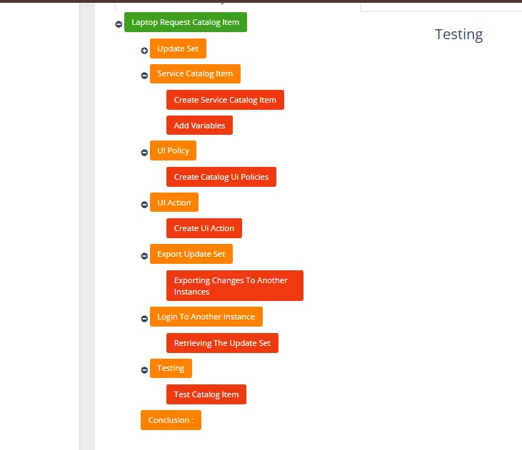

1. Variable Configuration Page

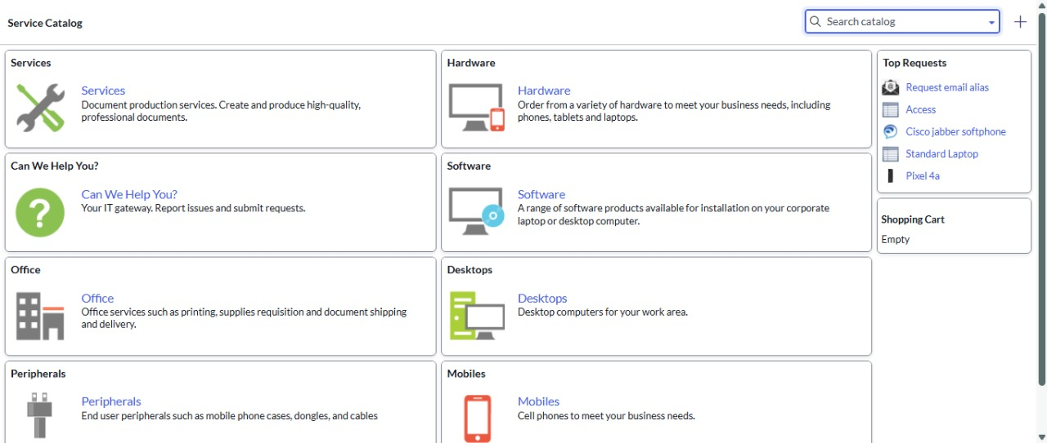

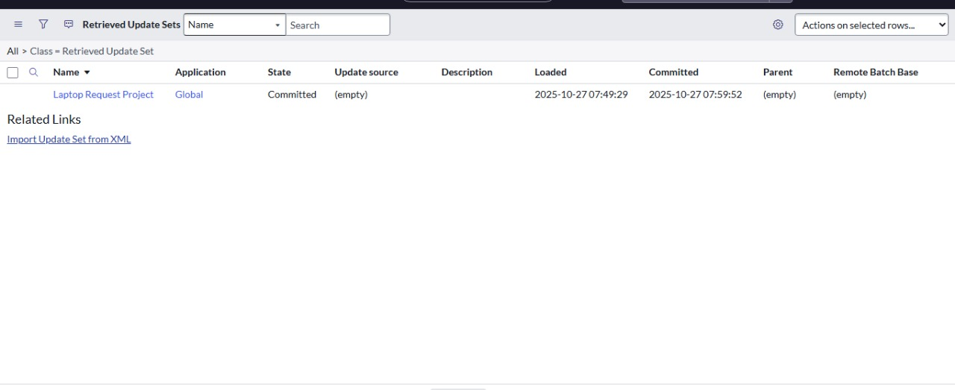



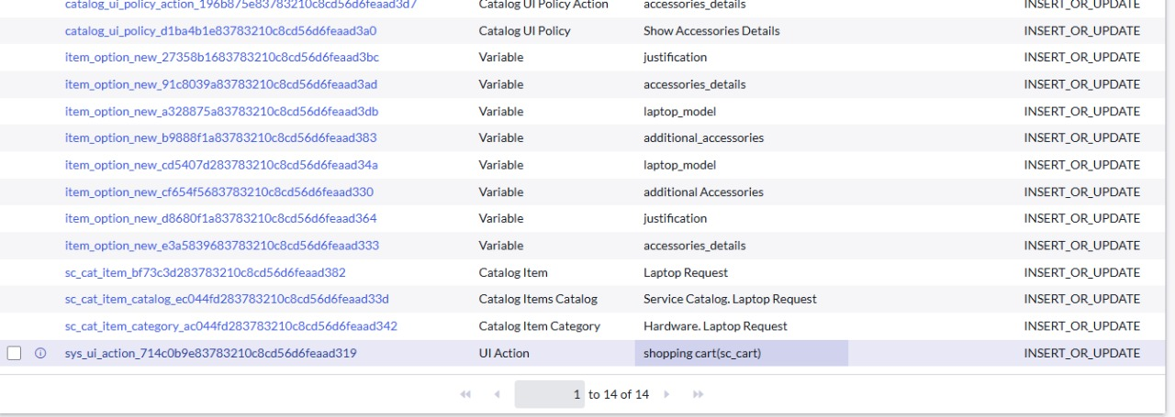

1. Approval Page

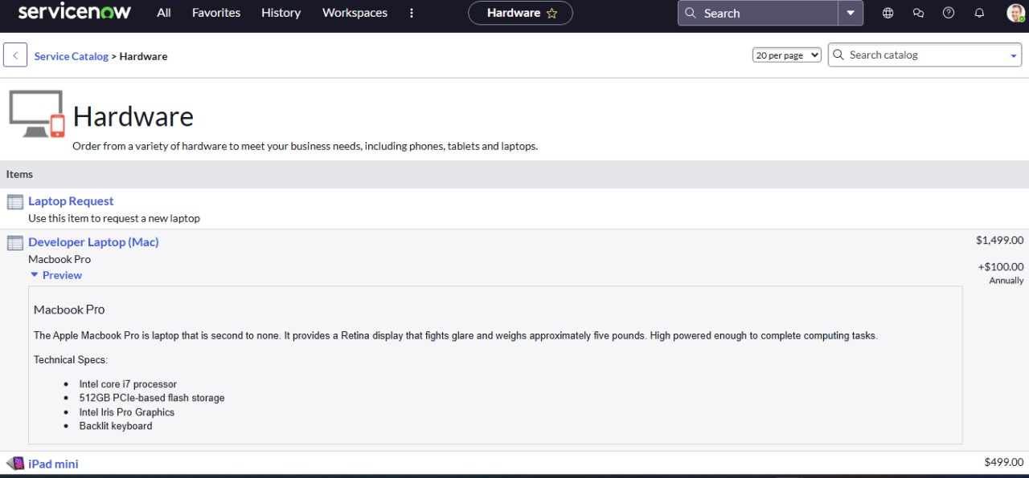

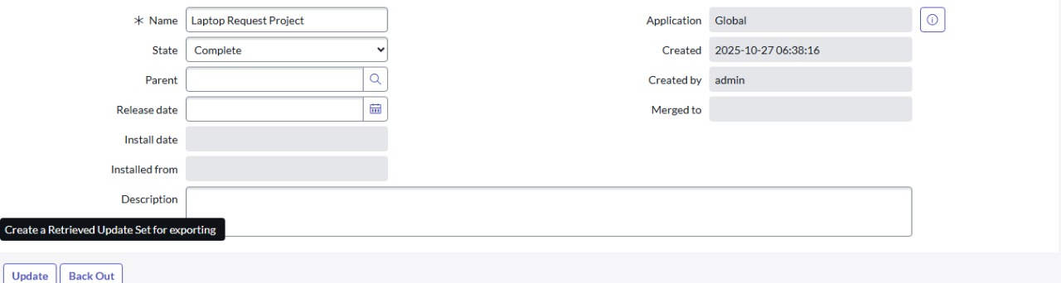

1. Notifications in Action

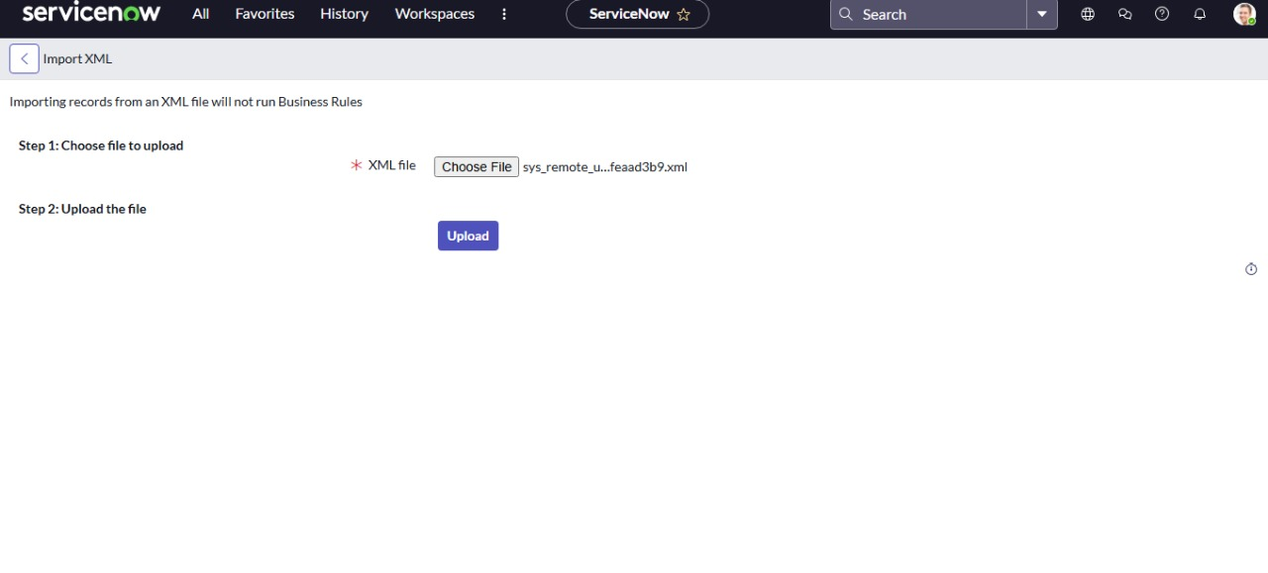

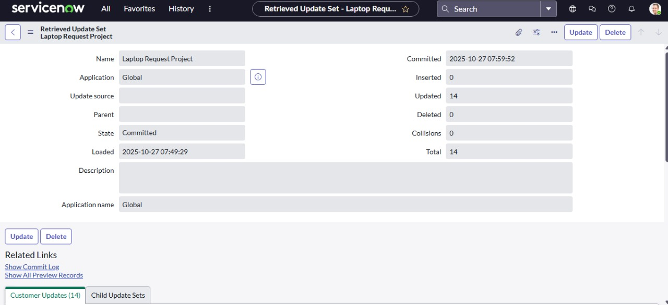

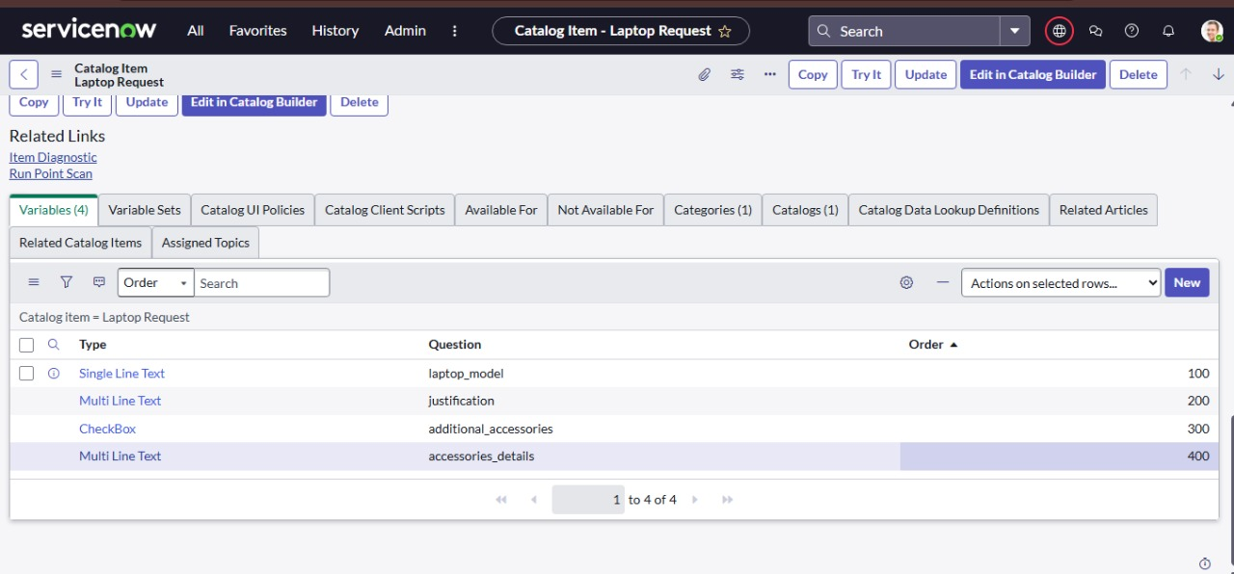

Request History Page

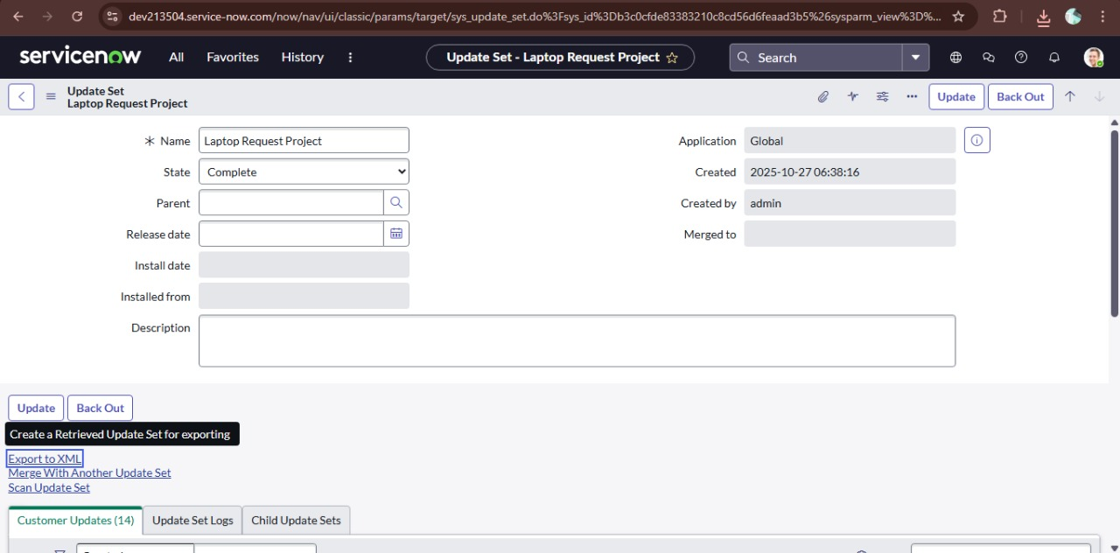



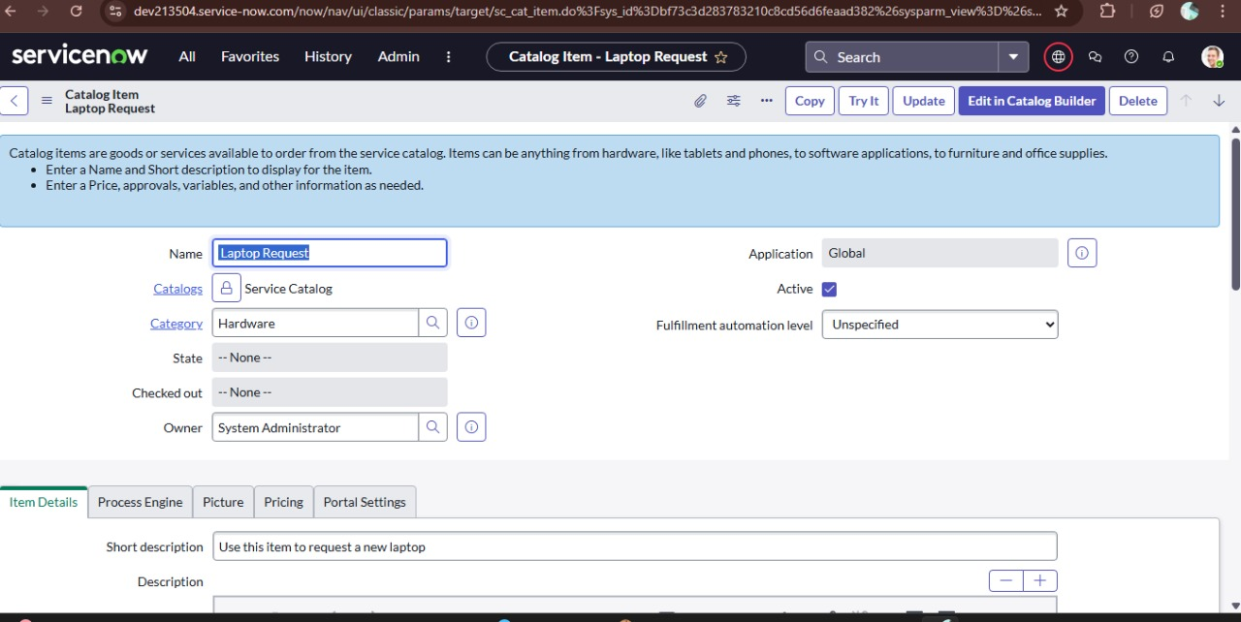

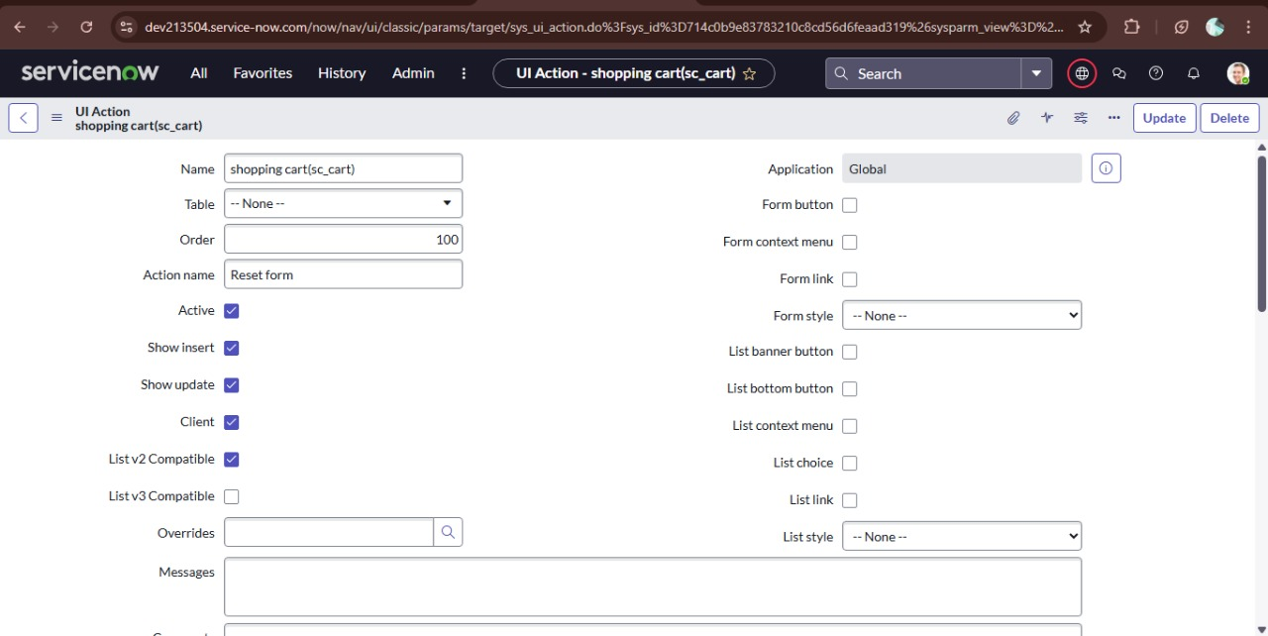

## ****8. TESTING****

* Conducted both functional and non-functional testing.
* Verified form validation, workflow routing, and notification triggers.
* Performed user acceptance testing (UAT) with end-users and administrators.
* Ensured system reliability and data consistency after multiple test submissions.

## ****9. RESULTS AND DISCUSSION****

* The implemented Laptop Request System successfully automates the hardware request process.
* Reduces manual paperwork and improves request tracking.
* Enhances transparency for users and efficiency for IT administrators.
* Future improvements may include integration with asset management and mobile accessibility.

**10. ADVANTAGES**

1. **Automation of Request Process:**  
   The system automates the laptop request and approval workflow, reducing manual intervention and processing time.
2. **Improved Transparency:**  
   Users can track their requests in real time, enhancing visibility and accountability.
3. **Centralized Management:**  
   All requests, approvals, and fulfillment data are managed from a single centralized ServiceNow platform.
4. **Time Efficiency:**  
   Automated approvals and notifications save time for both users and administrators.
5. **Error Reduction:**  
   With predefined forms and mandatory fields, data entry errors and miscommunications are minimized.
6. **Scalability:**  
   The system can easily handle increasing numbers of users and requests without performance issues.
7. **Security:**  
   Role-based access control ensures only authorized users can view or modify specific information.
8. **Easy Maintenance:**  
   Configuration items are stored in update sets, making deployment and maintenance simpler.

**11. LIMITATIONS**

1. **Dependency on Internet Connectivity:**  
   The system requires stable internet access to function, as it is hosted on the ServiceNow cloud platform.
2. **Limited Customization in UI:**  
   While functional, the UI customization options within ServiceNow’s catalog interface are somewhat limited compared to standalone web applications.
3. **Licensing Costs:**  
   ServiceNow platform licensing and maintenance fees may be costly for small organizations.
4. **Training Requirement:**  
   End users and admins need initial training to navigate and use the system efficiently.
5. **Workflow Complexity:**  
   Adding complex approval chains or integrations may require advanced ServiceNow development expertise.
6. **System Dependency:**  
   Any platform downtime or upgrade may temporarily affect system accessibility.

**12. FUTURE ENHANCEMENT**

To further improve the *Laptop Request System*, the following enhancements can be considered:

1. **Integration with Asset Management:**  
   Automatically link approved requests with the asset inventory to track laptop allocation and availability.
2. **Mobile App Support:**  
   Enable users to submit and track requests through the ServiceNow mobile app for convenience.
3. **Advanced Reporting Dashboard:**  
   Add analytical dashboards to monitor request trends, approval times, and inventory levels.
4. **Chatbot Integration:**  
   Include a virtual assistant to help users fill forms, check request status, or find information quickly.
5. **Dynamic Approval Flows:**  
   Automatically adjust approval routing based on department, cost, or request type.
6. **Self-Service Knowledge Base:**  
   Provide articles and FAQs about laptop specifications, policies, and troubleshooting to assist users.

**13. Conclusion**

The *Laptop Request Management System* developed using ServiceNow effectively streamlines the process of requesting and approving laptop hardware within an organization. By digitizing the entire workflow, the system eliminates manual paperwork, enhances transparency, and ensures efficient communication between users and administrators.

The successful implementation demonstrates the flexibility and scalability of the ServiceNow platform for automating IT service processes. While the system meets its core objectives, future improvements—such as integrating asset management and mobile accessibility—can make it even more powerful and user-friendly.

Overall, this solution represents a step forward toward a fully automated, transparent, and efficient IT service management environment.

**14. References**

1. ServiceNow Documentation. *Service Catalog Management Overview.* Retrieved from: https://docs.servicenow.com/
2. ServiceNow Developer Portal. *Creating Catalog Items and Workflows.* Retrieved from: https://developer.servicenow.com/
3. ITIL Foundation Guide. *Service Request Management Best Practices.*
4. OpenAI (2025). *AI-Assisted Technical Documentation Support.*
5. Organization-Specific Internal Documentation (if applicable).